**LETSUPGRADE LINUX ADMINSTRATION**

**DAY 3 ASSIGNMENT**

**ANS 1 .**

**Creating And Verifying** myfile **By Using touch command**

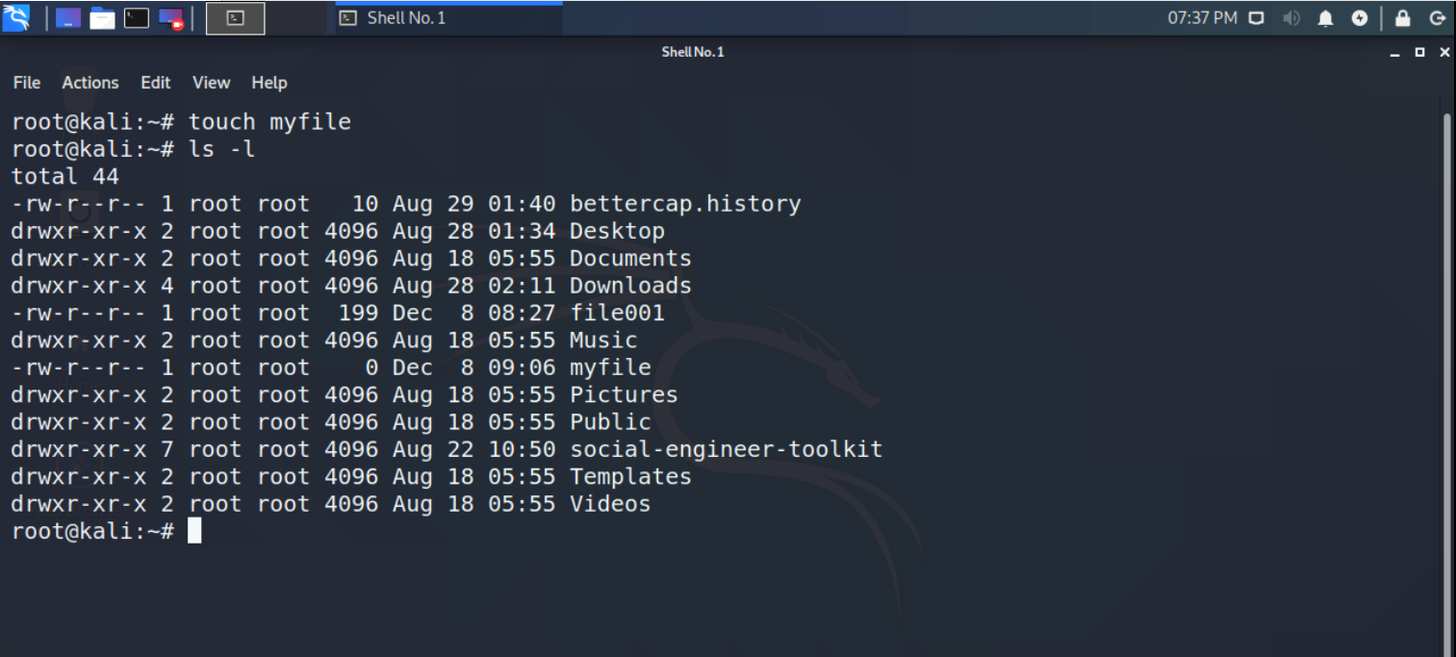

**ANS 2.**

**Opening The File Using Vi Editor**

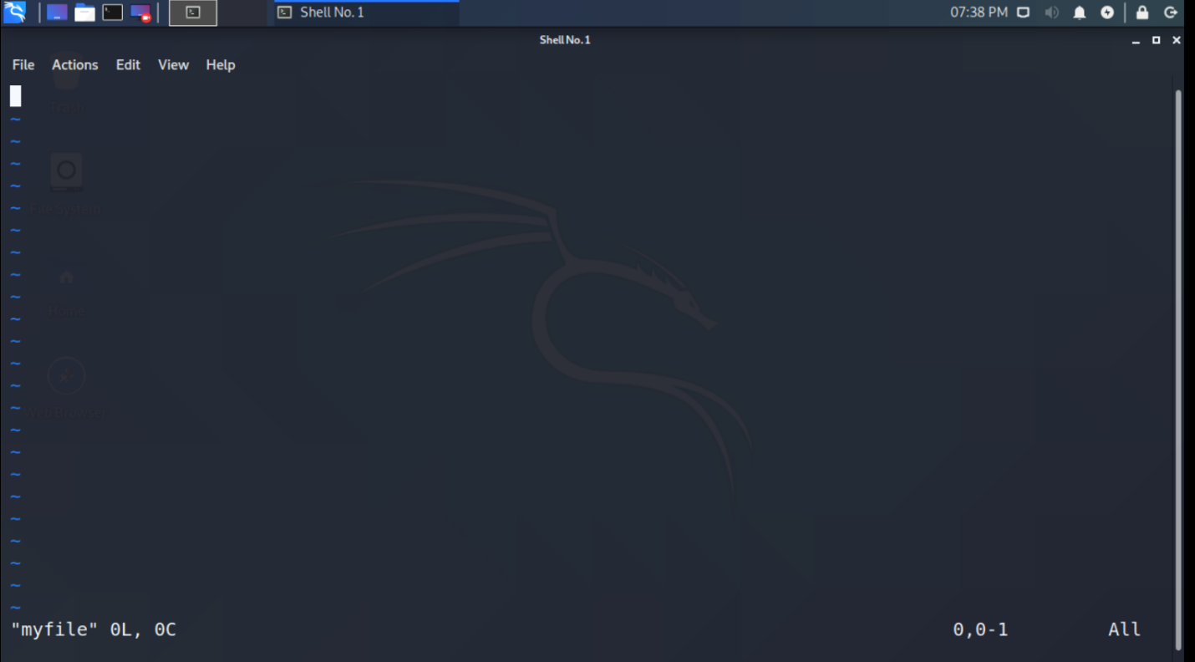

**ANS 3 .**

**Writing The Details And Saving It By Using :wq**

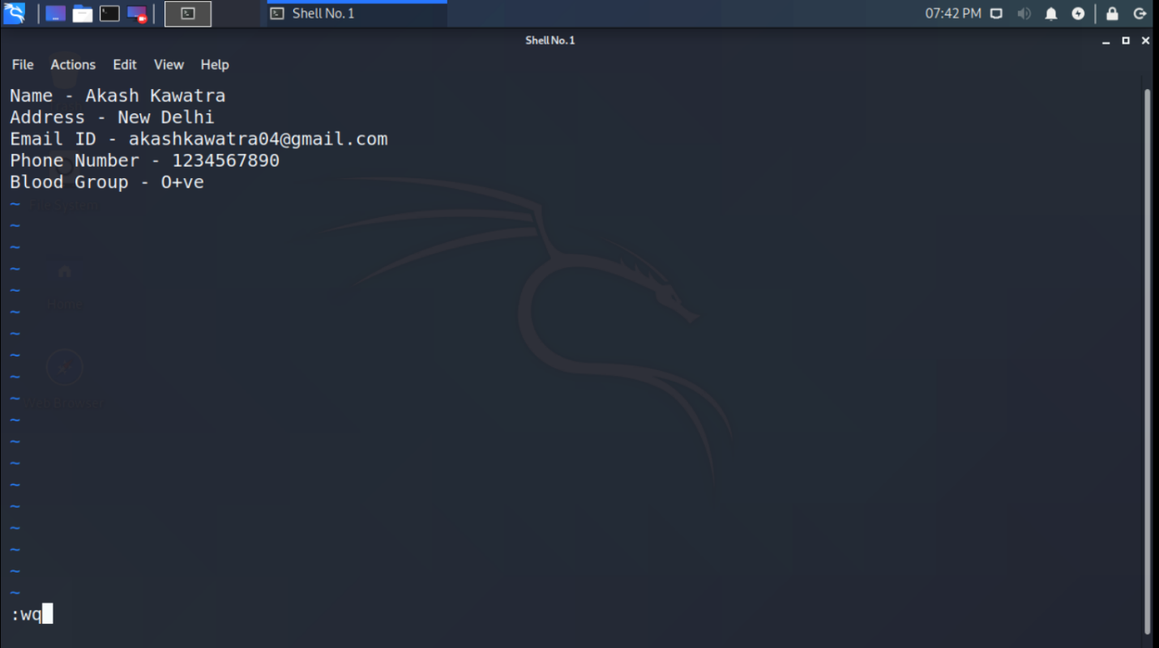

**ANS 4.**

**Creating one single expression to find the name and blood group line**

